Exercise Solution

Task :
Find the expression for the following truth table and simulate it.
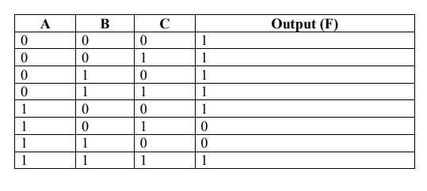
Simplification of truth table:

- Simplifying the truth table through POS
- Taking the combinations tat have 0 as output.

= (~A+B+~C) . ( ~A+~B+C)
= (~A+(B+~C)) . (~A+(~B+C))
= ~A + ((B+~C) . (~B+C))
= ~A + (B.~B + B.C + ~B.~C + C.~C)
= ~A + ( 0 + BC + ~B~C + 0)
= ~A + ( BC + ~B~C)
- Prove by truth table:

A | B | C | ~A | ~B | ~C | BC | ~B~C | BC+~B~C | F
0 | 0 | 0 | 1 | 1 | 1 | 0 | 1 | 1 | 1
0 | 0 | 1 | 1 | 1 | 0 | 0 | 0 | 0 | 1
0 | 1 | 0 | 1 | 0 | 1 | 0 | 0 | 0 | 1
0 | 1 | 1 | 1 | 0 | 0 | 1 | 0 | 1 | 1
1 | 0 | 0 | 0 | 1 | 1 | 0 | 1 | 1 | 1
1 | 0 | 1 | 0 | 1 | 0 | 0 | 0 | 0 | 0
1 | 1 | 0 | 0 | 0 | 1 | 0 | 0 | 0 | 0
1 | 1 | 1 | 0 | 0 | 0 | 1 | 0 | 1 | 1

OUTPUT:





